A Study on Disney’s Transition over the Decades
1.Project Overview

“The Study analyses the Disney’s evolution across decades by using Excel and Power BI. The Project focuses on their most high -performing combination of Movies and Series and the impact of critical variables including Genre, ratings, geographical Locations, Language ,runtime and other factors on their overall success” .
2. Tools Used - Microsoft Excel - Power BI

3. Dataset - Source: ‘Disney_Plus_shows’- Data contains: key columns like imdb_id, Title, Type, Rating, Year, Genre, language, Country, Imdb rating, votes etc
4. Steps Followed - Cleaned data in Excel (e.g., removed blanks, corrected the formatting and removed inconsistency in the data)- then Imported cleaned data into Power BI – then created a duplicate table for further analysis on genre, geographical locations etc and with use of the tables Built dashboards using different types of charts, slicers, Tables and matrix
5. Key Insights
Insight 1 - The pattern of Disney Releases over the year shows a massive spike in content product leading up to 2020.
Insight 2 – When comparing the Movies vs Series, Disney has produced 13 Movies Title’s while only 7 series where produced, so focus is more on Movies.
Insight 3 – The Type and Rating relation bar chart confirms that “G” (general Audience) and “PG” rating dominate the library.
Insight 4 - With an average score of Imdb rating of 6.44 and Metascore of 60.90, the data suggest Disney maintains a consistent “above average” quality across their movies and series.
Insight 5 – The Country Wise classification shows USA being the most favored geographical location for Disney.
Insight 6 – The Treemap Shows that Family, Comedy and Animation are the largest blocks, but inclusion of the other genre’s indicate the diversification of their portfolio.
Insight 7 - The scatter Plot shows the correlation between ratings and Types showing a cluster of Titles in 6-8 ratings.
Insight 8 – The Rating & Runtime bar chart reveals G-rated content actually hold a massive share of run time.
Insight 9 – The Titles Released in English & French or English & Arabic outperform the average ratings

6. Screenshots
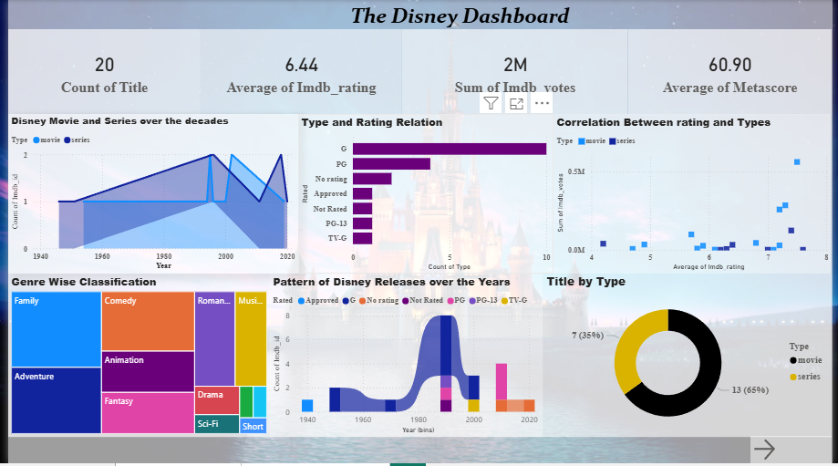
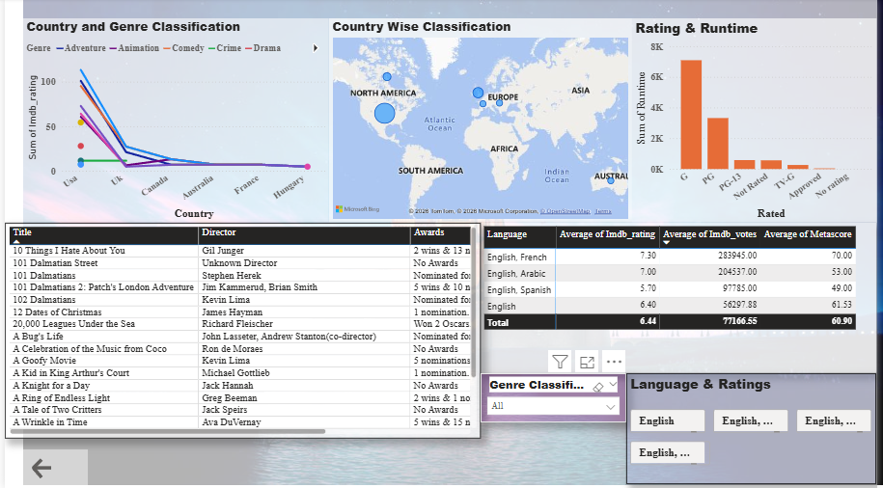

7. Files Included – ‘disney_plus_shows assignment final.csv’– Cleaned data and basic analysis - ‘Disney transition Dashboard.pbix’ – Power BI dashboard - ‘Project Report Disney.docx’– Project description
8. How to Use - Open ‘disney_plus_shows assignment final.csv’ to view the cleaned data. - Open ‘Disney transition Dashboard.pbix’ in Power BI Desktop to explore the visuals.

Thank You

